Machine Learning COSC 6342

Fall 2017

Homework -2 Report

Priscilla Imandi

PS ID : 1619570

Part 1a : Perceptron

Accuracy for the simple model is 92.11

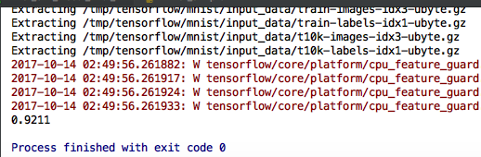

Tensorboard Visualisation

1. mnist_softmax_graph

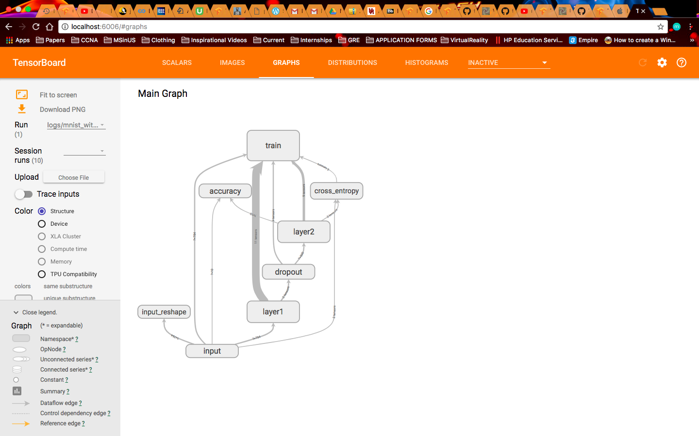

1. mnist_softmax_histogram

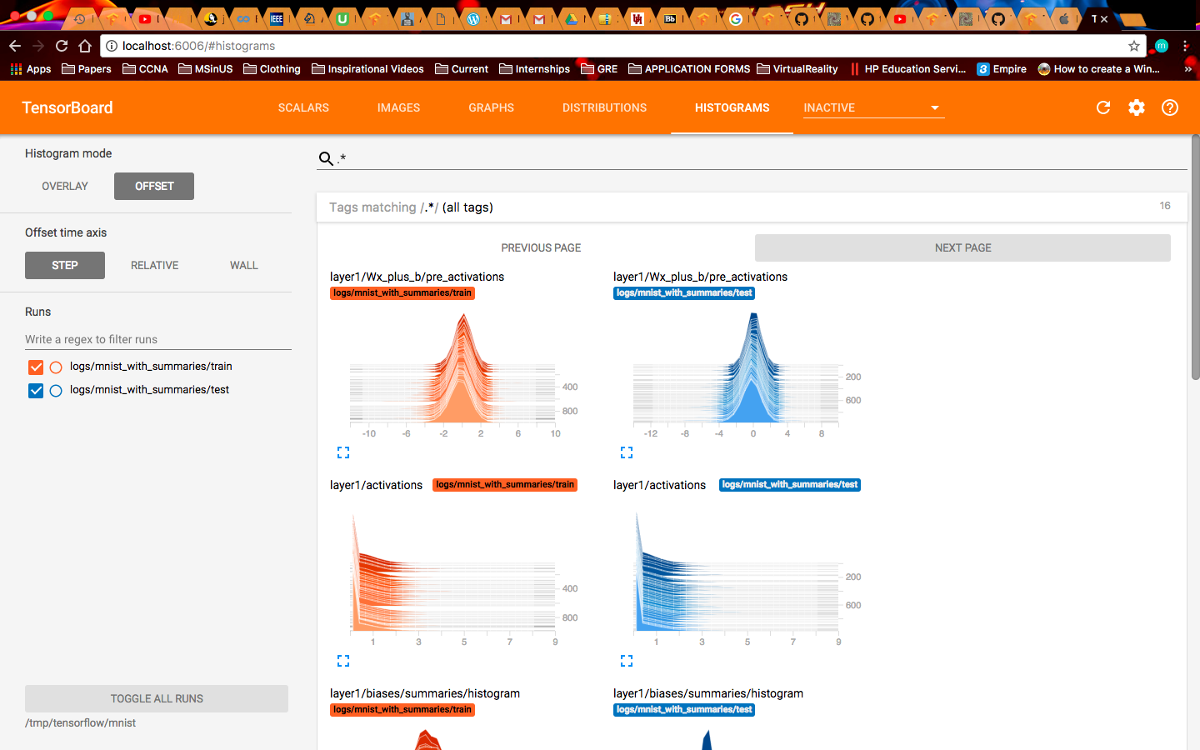

1. mnist_softmax_scalars

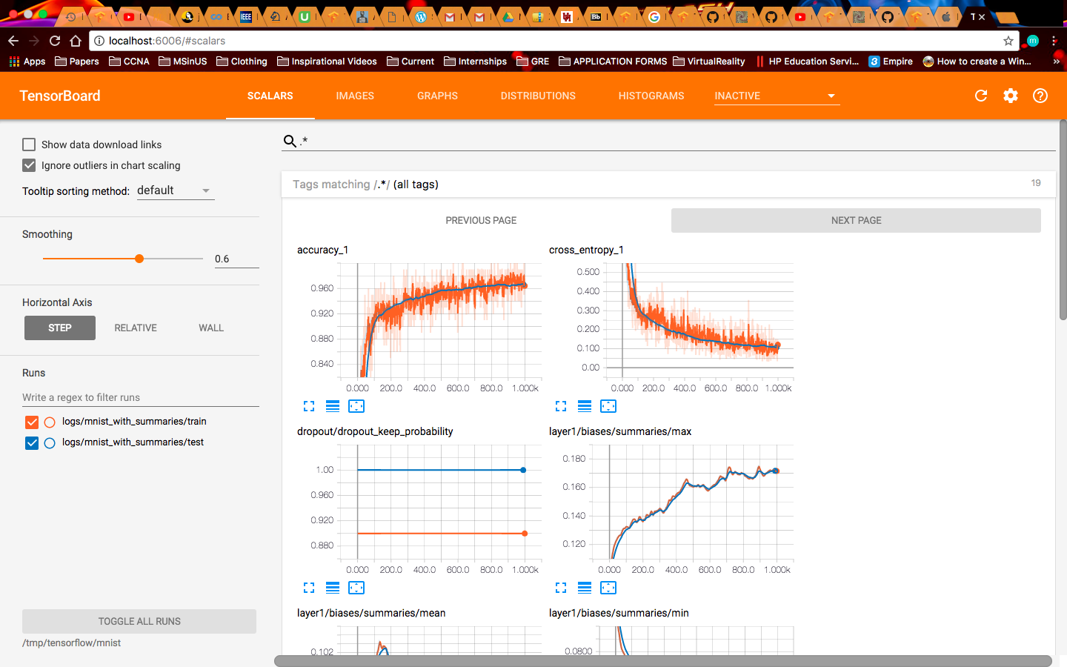

1. mnist_softmax_image

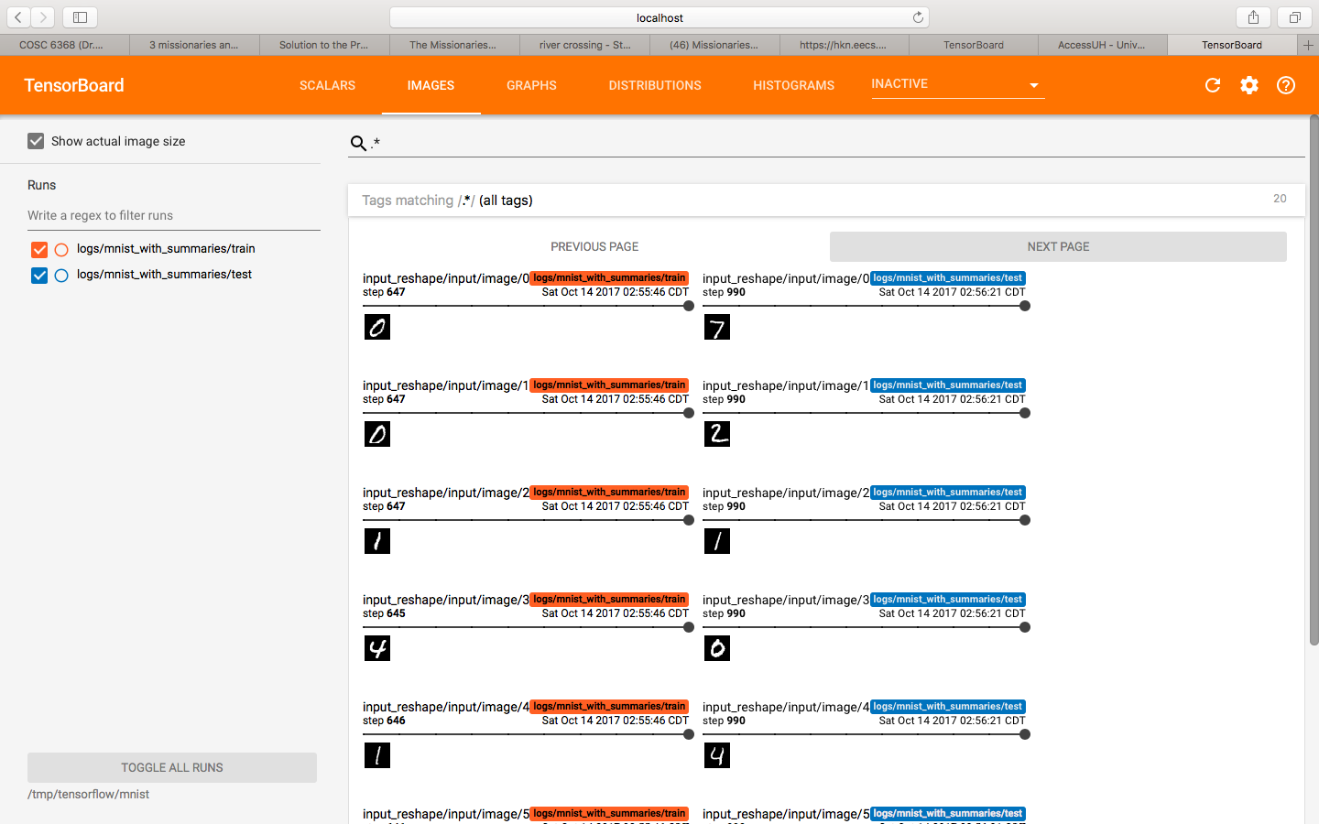

1. mnist_softmax_distributions

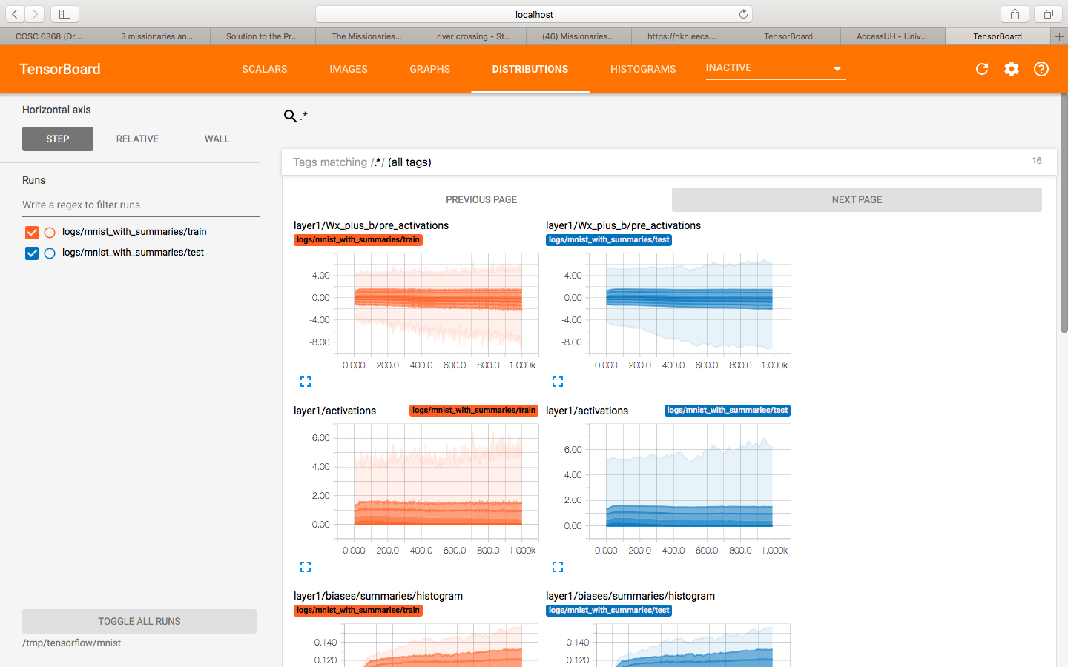

Part 1b : Convolutional Neural Networks

Accuracy is 99.03

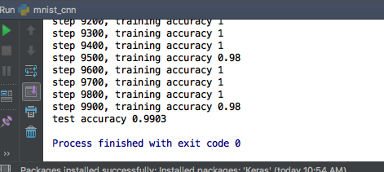

1. cnn_scalars

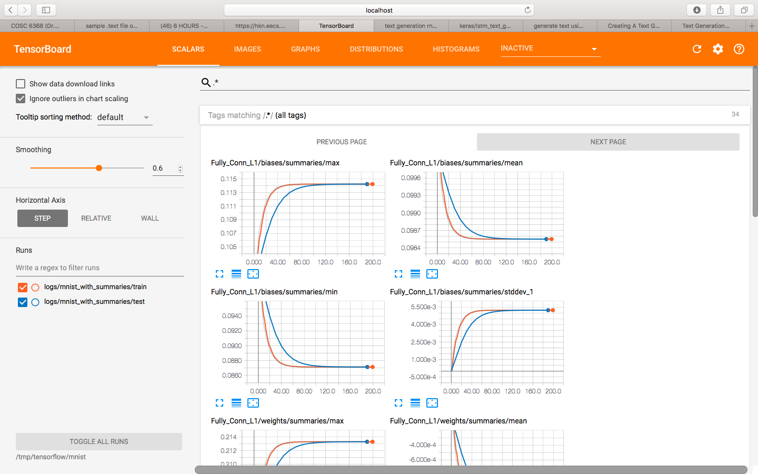

1. cnn_image

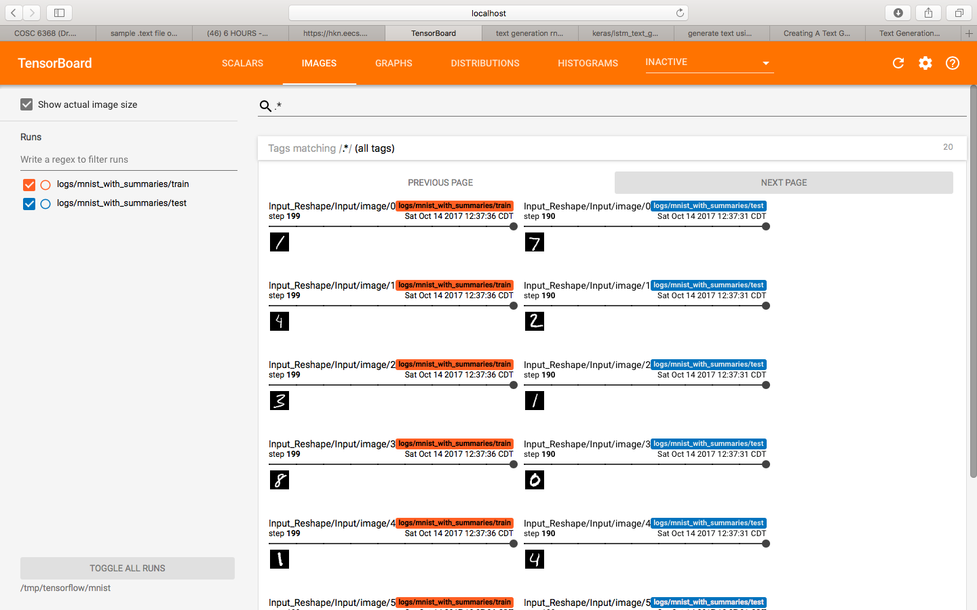

1. cnn_graph

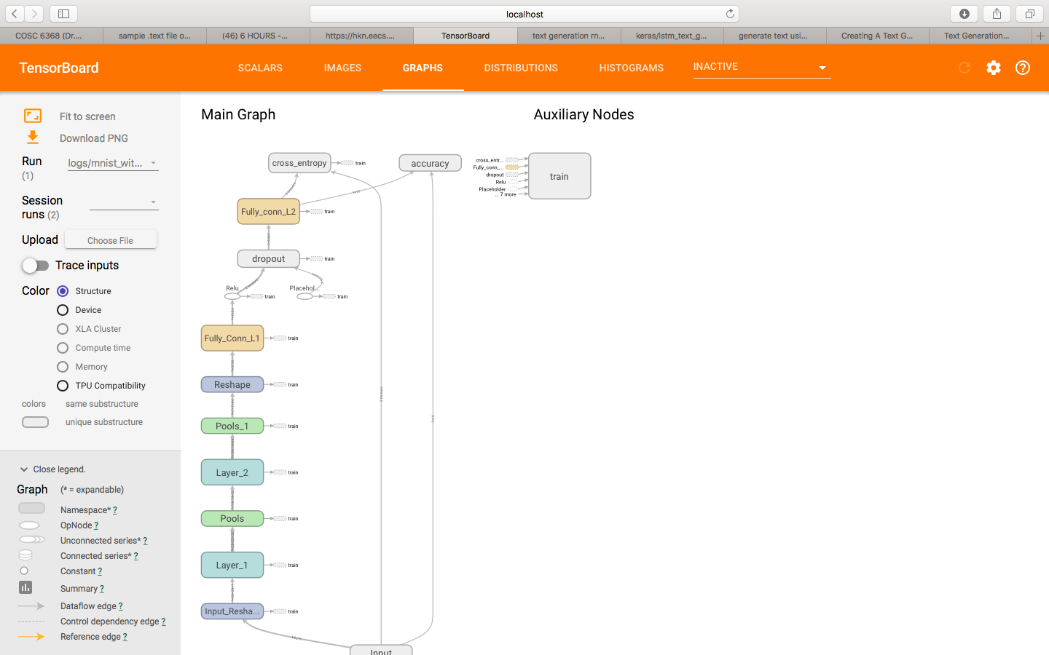

1. cnn_distributions

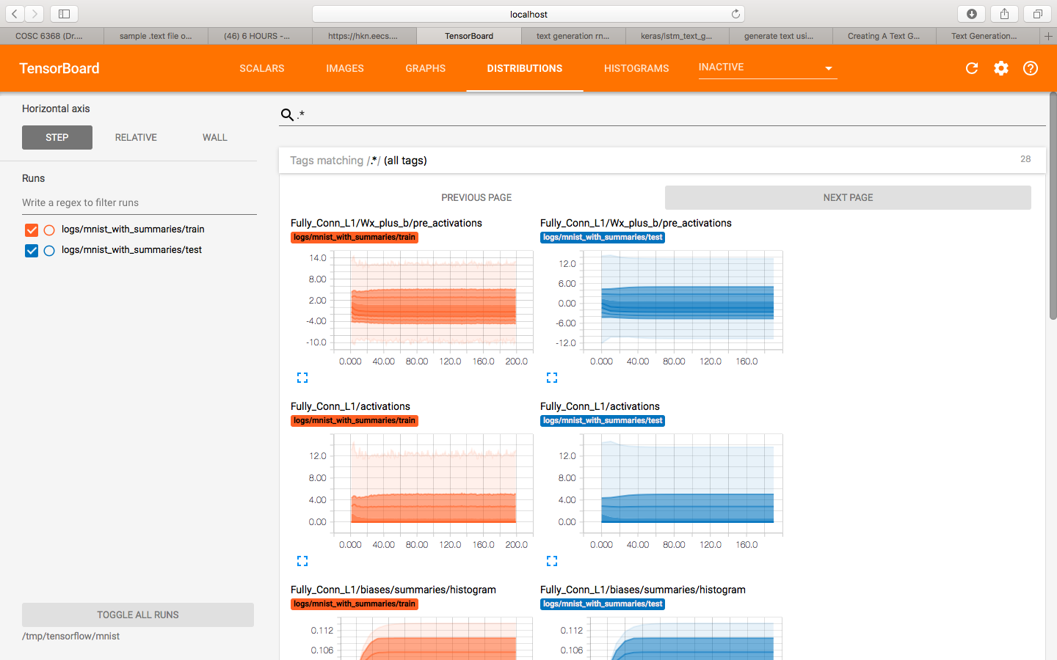

1. cnn_histograms

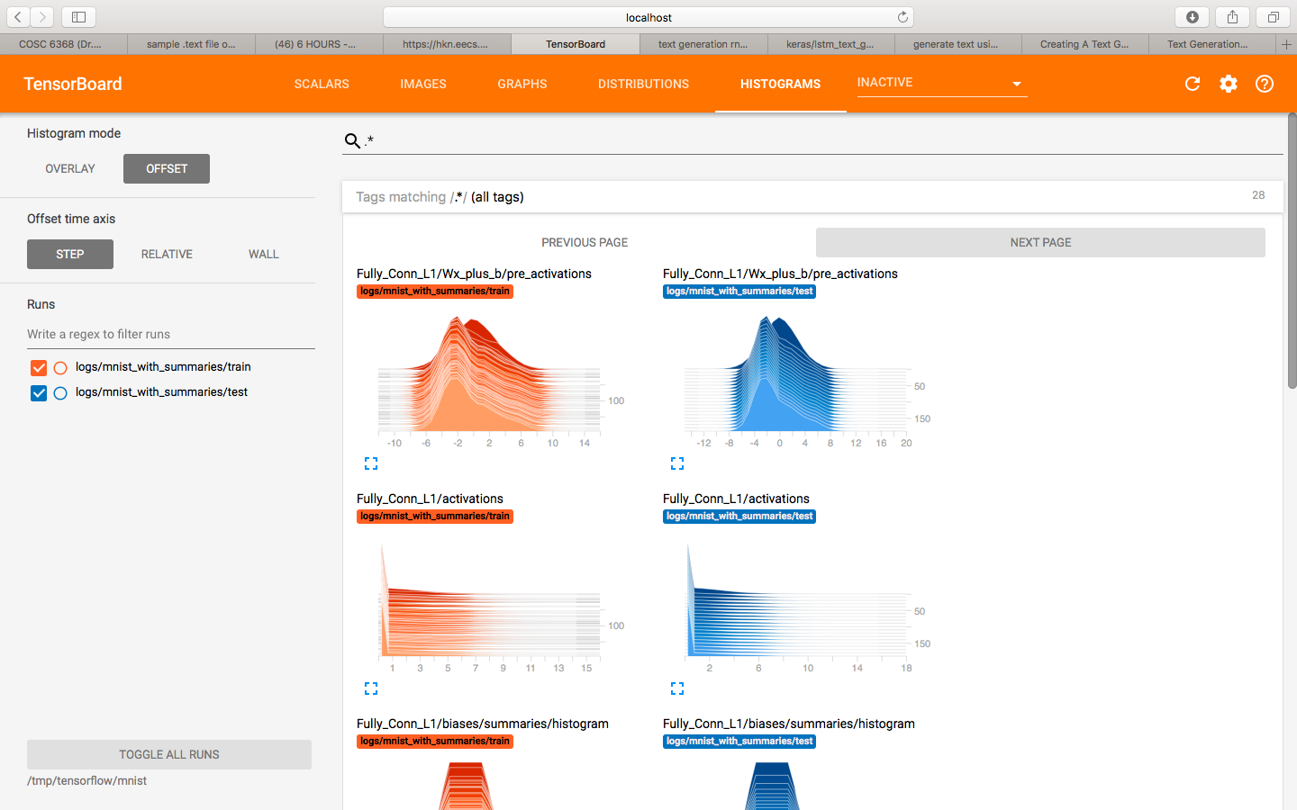

Part 1c:

The convolutional Neural Networks model performed better because it trained through multiple layers rather than a single layer like the first model.

But having multiple layers doesn’t always mean that accuracy increases, it might sometimes also lead to over fitting, even though it performs very well on training data.

The output in MNIST is the probability of the image being associated with a class. If the image goes through multiple layers the probability of it being the true output increases as multiple comparisons are made.

Part 2 :

A collection is taken with filename <alad10.txt> .

For larger data sets the output is better. With more iterations the model learns better.

Output getting generated after 35 iterations is:

ulsion, and even

worse consequences of enetae it a rnatatinn not anotration one or to to ten e e to ot t in tet rrine to toarerene to tation in neanintionater oreianion one ertrree or i trare arenternerartain tarter a tian earionerenan in to an no ention an at eeationatian an artrane teart in atereene onern an it a tent an inat one a treation one trear neare an or naterrate to too or to to a rene it a no errantainere orion e reotein an.